Project Report

|  |  |
| --- | --- |
| Project Title | Problem Manage a Server Outage Scenario & an Issue & Change Request Management System |
| Qualification Name (NICF) | Advanced Certificate in Software Applications (Development and Deployment) |
| Product Name |  |
| Module Name (NICF) |  |

|  |  |  |  |
| --- | --- | --- | --- |
| Student name | | Assessor name | |
|  | |  | |
| Date issued | Completion date | | Submitted on |
|  |  | |  |
|  | |  | |
| Project title | Student Registration Form Development | | |

|  |
| --- |
| Learner declaration |
| Student signature: Date: August 17, 2023 |

Content



Project Background

**Scope of the project**

* Explain the principles of problem management.
* Use a variety of tools, processes and techniques to identify problems.
* Conduct investigation, analysis and resolution.
* Explain the steps to investigate and diagnose problems.
* Prioritize and classify change requests.
* Prepare a solution to address the root cause of the problem.
* Document and monitor problems
* Explain best practice for documenting problems.

Project Objective

Tools & platform used

Used to develop software tools for Java programs.

1. Excel Sheet

Use excel sheet to log issue tracking documents and known error database

1. Diagram.net

Using diagram.net to draw a fishbone to analyses the root cause of the problem

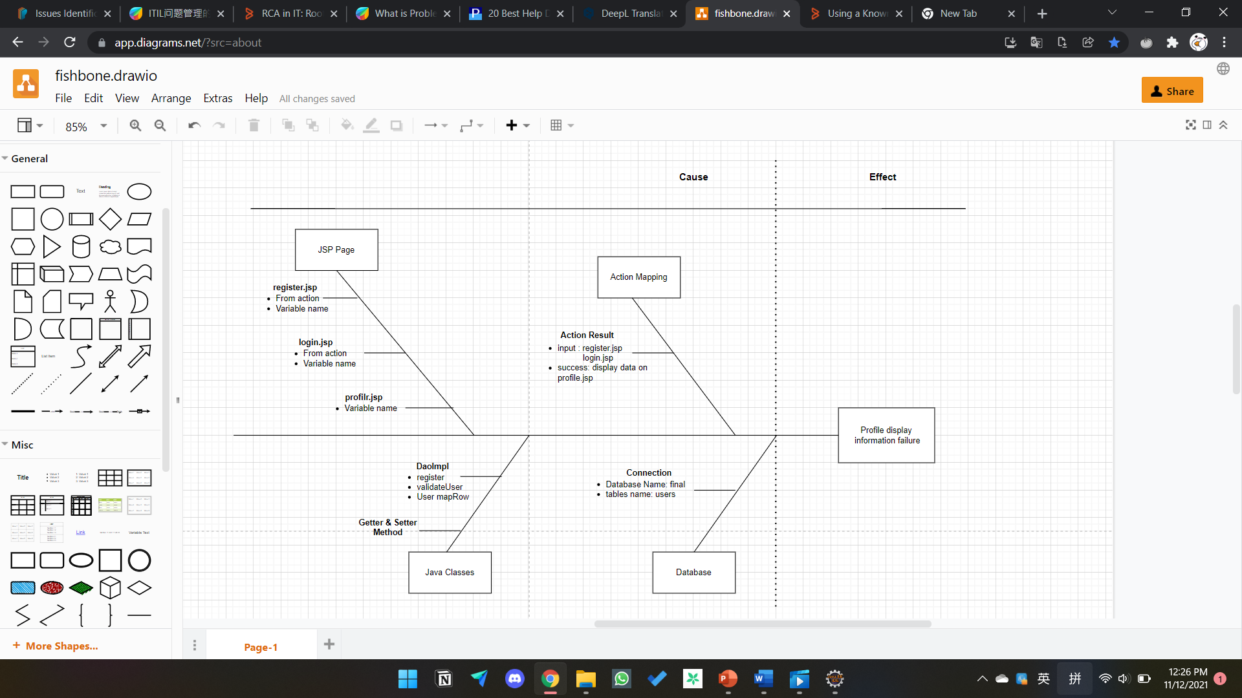

Project Requirements Specifications

**3.1 Functional requirements**

**Users (Software Programmer)**

**Register:.**

**Login:**

**Logout:**

**Posting messages :**

**Search users**

**Update profile:**

**Administrator**

**Login:.**

**Add user:**

**Delete user:**

**Modify user:**

**3.2 Non-functional requirements**

**Safety requirements**

**The database holds personal information of users,.**

**Performance attributes**

**Availability:**

**Maintainability: the community portal is regularly monitored and maintained by the administrator.**

**Usability: the ABC community portal can include a large number of users and has a large capacity to store user information.**

Task 1: Principles of Problem Management

4.1 What is Problem Management?

4.2 The Three Phases of Problem Management

1. Problem Identification
2. Problem Control
3. Error Control

4.3 Principles of Problem Management

1. Problem Identification
2. Problem Investigation

High priority or high-risk problems should be resolved first, as their impact on the service is highest. The speed at which problems are investigated and diagnosed depends on the priority assigned. Correctly categorising problems makes it easier to identify trends.

1. Problem Analysis

.

1. Problem Resolution
2. Review

4.4 Problem Management Example

Problem Identification:

1.The user is logged in and when viewing their profile, the user data is not displayed.

2. Unable to view errors on invalid user id and password.

Screenshot of client-side screen

User Login:



User profile page:

Task 2: Tools, Process & Technologies

1. Problem Logging

Techniques = Issue Tracking System

Tool = Excel Sheet

Using an Excel sheet to make a tracking document template is an important tool for issue identification.

Process:

* 1. receive an email
  2. Verify.
  3. Create or
  4. Repairing the
  5. When the issue is fully resolved, it will be marked as resolved in the issue tracking system.

|  |  |  |  |  |  |  |  |  |  |  |
| --- | --- | --- | --- | --- | --- | --- | --- | --- | --- | --- |
| Issue Identification and Tracking Document | | | | | | | | | | |
| Created By: | | |  | | Last Update By: | | |  | | |
| Date Created: | | |  | | Last Revision Date: | | |  | | |
| Issue No. | Issue Description | Issue Type | Identified By | Date Identified | Issue Assigned To | Target Resolution Date | Priority | Status | Date Resolved | Resolution Description |
| 1 | The registration form is not connected to the database | Technical Issues | Software Tester Team |  | Software Development  Team | 8. | High | Resolved |  | Correcting code for DAO linked databases |
| 2 | Invalid login details error not displayed | Technical Issue | Customer | 7-8-2023 | Software Development  Team | 8-8-2024 | Medium | Resolved | 8-8-2023 | Error messages code attached |
|  |  |  |  |  |  |  |  |  |  |  |
|  |  |  |  |  |  |  |  |  |  |  |

1. **Problem Investigation**

Techniques = Root Cause Analysis

Tool = Fish Bone

Process:

1. Clearly define the problem statement.

2.

1. Problem Resolution

Techniques = Known Error Database

Tool = Excel Sheet

Process

1. Task 3: Investigate & Diagnose

1. **Investigate the problem**

1. **Diagnose the problem**

Diagnosing the root cause of the problem through debugging

**Add a breakpoint to the controller of the profile:**

**When debugging, see if the user id is getting fetched:**

1. Task 4: Explain Prioritize

**Priorities and categories problems:**

**Tier 1: Low priority issues**

* The first tier is for basic or minor problems.

**Tier 2:** **medium priority issues**

* The second tier is the major problems.

**Tier 3:** **High Priority Issues**

* The third tier is the critical problem

**Problems Categories Diagram:**

1. Task 5: Problem Management Solution

**Solution for Profile page display data failure:**

Solution for Invalid user information not display .

After modifying, then re-debug to check if the problem is solved

|  |  |  |  |  |  |  |
| --- | --- | --- | --- | --- | --- | --- |
| Known Error Database | | | | | | |
| **Ticket no.** | Issue Description | Issue Type | Root Cause | Workaround | Status | Date Resolve |
| 1. | The registration form is not connected to the database | Technical Issues | There is missing DAO code to connect to the database | Correcting code for DAO linked databases | Resolved |  |
| 2 | Invalid user information not display | Technical Issues | Error code was not attached for display error | Added the code in the login page | Resolved | 8.8.2023 |

1. Task 6: Systems will be implemented



1. Task 7: Best Practices in Problem Management

**Best practices and industry standards for problem management:**

1. **Clients should be separate from the person handling the incident**

1. **Solved problems need to be stored in the Known Errors database**

https://techqualitypedia.com/fishbone-diagram-ishikawa-diagram/